Title (max two lines)
John Surname¹, Emily FamilyName², Peter Smith¹, George Surname²
(1) Institution, Street and number, Zip-code City, Country
(2) Institution, Street and number, Zip-code City, Country
Contact: E. FamilyName ( autor@institution.edu )
Abstract. Please add author ORCIDs to the abstract's footer in the order of author list! File: Word for Windows 2003 (doc) or Word 2007 (docx) format. Page: A4 portrait, margins 2,54 cm. Title: paragraph centered, no indent, line spacing single – before 0pt below 8pt; font Times New Roman 14pt bold. Authors: paragraph centered, no indent, line spacing single – before 0pt below 8pt; font Times New Roman 12pt. Institutions: paragraph centered, no indent, line spacing single – before 0pt below 6pt; font Times New Roman 10pt italic. Contact: paragraph left, no indent, line spacing single – before 0pt below 18pt; font Times New Roman 10pt; first word „Contact“. Body: paragraph justified, first line indent 0,63cm, line spacing single – before 0pt below 6pt; font Times New Roman 12pt; first word „Abstract“. Figure body: paragraph centered, no indent, line spacing single – before 0pt below 6pt. Figure caption: paragraph justified, first line indent 0,63cm, line spacing single – before 0pt below 12pt; font Times New Roman 10pt. Title „REFERENCE“: paragraph justified, no indent, line spacing single – before 12pt below 6pt; font Times New Roman 10pt uppercase. Reference: numbered list [1]; paragraph justified, first line hanging 0,63cm, line spacing single – before 0pt below 8pt; font Times New Roman 10pt.
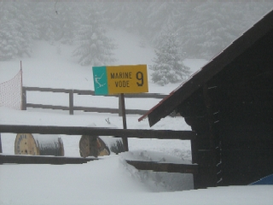
Figure 1. Include figure if needed. Caption centered, 10pt.
For referencing in the text please use brackets: [n], where n – reference number. References style is shown in the references list below. Figures and references are not mandatory, but would help readers.
For abstract submission please visit http://photonicsworkshop.ipb.ac.rs.
REFERENCES (max 6 lines)
- Lj. Author, Book title, Publisher, New York (2018).
- Ž. Author, Š. Author et al., J. Appl. Opt. A 33 (1989), 357–376.
- Nj. Author, Proc. SPIG conf. 23 (1996), 64–66.
- M. Author, K. Autor et al., “Entropial principle in photonics”, www.entropiya.dot (accessed: 11.11.2018.).
- J. Author, Proc. Photonics09 Conf. (2009), 91 (abstract).

